Commission announces groundbreaking biomethane target: ‘REPowerEU to cut dependence on Russian gas’

8th of March 2022

Today, the European Commission announced a target for the production of 35 billion cubic metres (bcm) of biomethane within the EU by 2030 as part of its REPowerEU plan. The biomethane value chain welcomes this target, which is a historic step forward and shows EU leadership. . The target will replace 20% of natural gas imports from Russia by a sustainable, cheaper and locally produced alternative. Biomethane also helps to reduce exposure to food price volatility because digestate, a co-product of biomethane production, replaces currently expensive synthetic fertilisers.

We are a group of about 30 companies and organisations, coordinated by European Biogas Association and Common Futures. Last December we published the Biomethane Declaration. In this Declaration we called for a scale-up of biomethane to 350 TWh by 2030, which roughly equals 35bcm. As part of the 35 bcm target, the Commission wants to double EU biomethane already in 2022. This requires urgent and immediate action. Also, the biomethane target should be integrated in the EU Renewable Energy Directive and other legislation. We are keen to continue to cooperate with the European Commission and Member States to fulfill the new target.

Mobilising sustainable biomass feedstock and investing in new production capacity
The target can be achieved largely based on waste and residue feedstocks (see annex). Also, a role can be foreseen for sustainable crops produced in sequential or double cropping schemes without competition with food and feed production.
Today the EU produces 3 bcm of biomethane. Scaling-up to 35bcm requires the mobilisation of sustainable biomass feedstock, mostly waste and residues, plus building about 5,000 new biomethane plants. From a technical perspective this is feasible during the next eight years. And it’s cost-effective as well. Some €80 billion in capital investments would be needed, European money spent in our domestic economy. It allows us to produce biomethane at a cost that is considerably lower than the natural gas price over the past several months, even without the CO₂ price. And in addition to building new integrated biogas-biomethane installations, it would also be possible to cost-effectively add methanation units to existing biogas plants. We also call for a rapid commercialisation of gasification technology, which allows for biomethane production from woody residues.

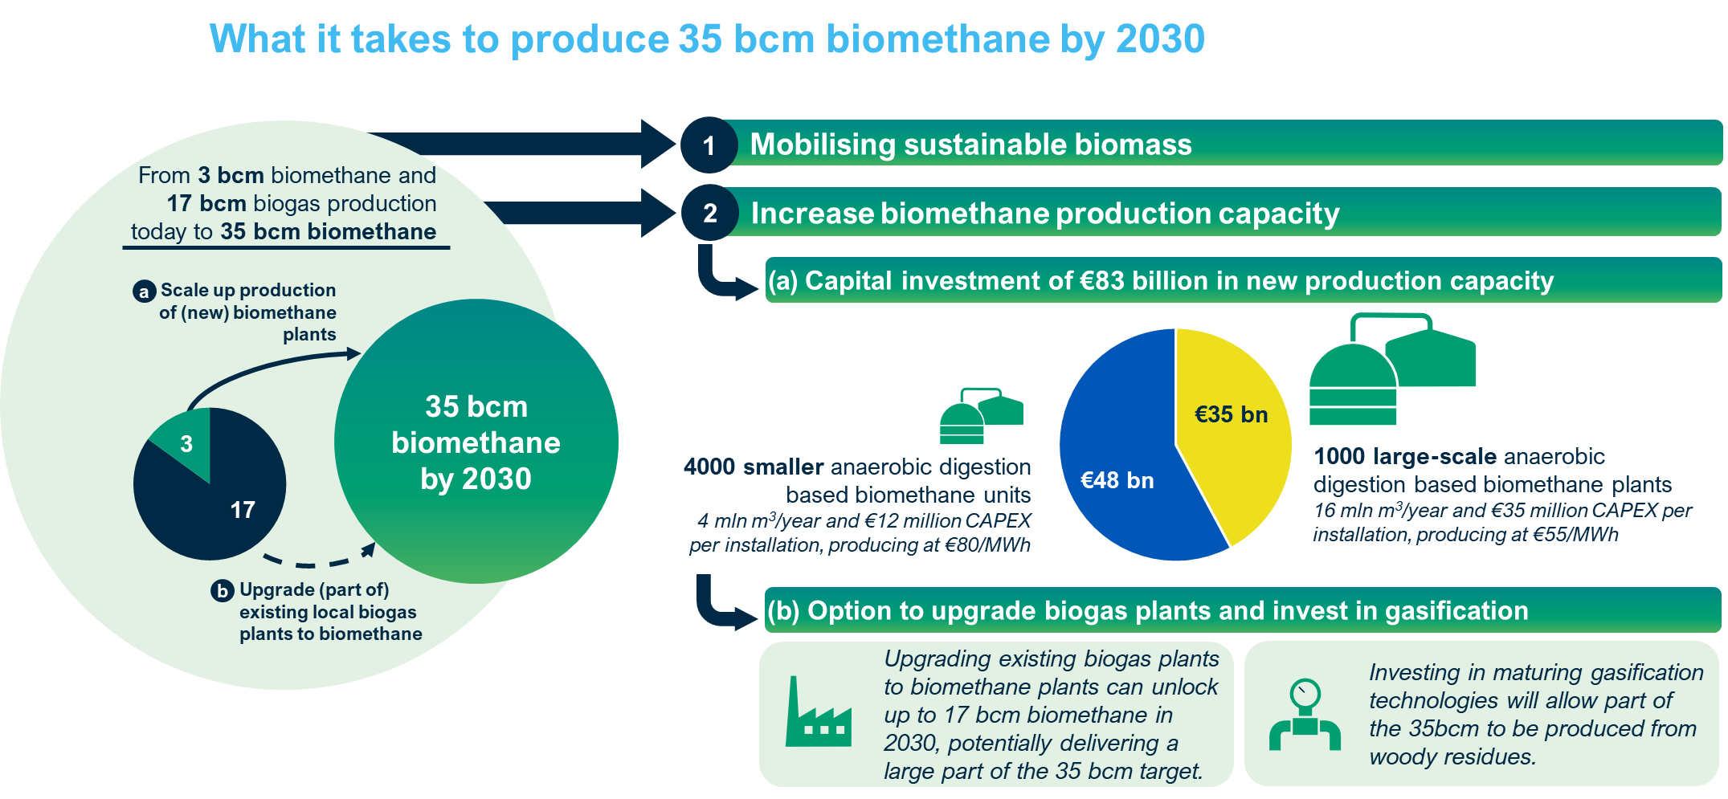

For more information, please contact:
Harmen Dekker, European Biogas Association: dekker@europeanbiogas.eu; +31 654331782
Daan Peters, Common Futures: daan.peters@commonfutures.com; +31 634489780

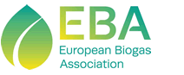

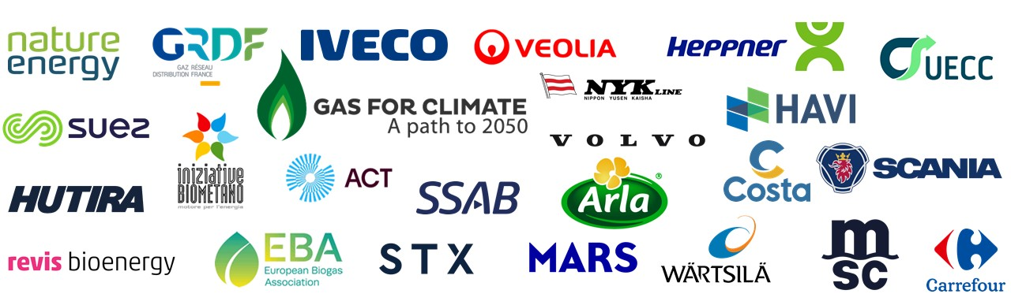

breakdown of 35 bcm based on available biomass feedstock
The table below shows how the EU can produce 35 bcm of biomethane from sustainable biomass feedstocks sourced from within the EU. This feedstock mix below is largely based on previous work by Gas for Climate and underlying data and studies, plus additional insights on the potential from industrial wastewater. The assumptions used on feedstock availability are highly conservative.
Feedstock | Biomethane | Assumptions | Source
Manure | 16 bcm | Solid manure: 50% of all the solid manure potential at farms with more than 100 Lifestock Units (LU). Liquid manure: 100% of all the liquid manure at farms with more than 100 LU. Only manure that is collected from stables | Gas for Climate, based on Elbersen et al., 2016: "Outlook of spatial biomass value chains in EU-28. See here.
Agricultural residues | 10 bcm | Largest share of straw is left on agricultural soils. From sustainably collectable straw, 50% of cereal straw is considered to be used for biomethane. Remainder mostly for animal bedding. | Gas for Climate  (Iqbal et al. 2016): "Maximising the yield of biomass from residues of agricultural crops and biomass from forestry  (Spottle et al. 2013). "Low ILUC potential of wastes and residues for biofuels: Straw, forestry residues, UCO, corn cobs"  (Elbersen et al., 2016): "Outlook of spatial biomass value chains in EU-28"
Food waste | 2 bcm | 7% of food waste in the EU today | Gas for Climate  Eurostat  (CE, Delft, 2017): "Optimal use of biogas from waste streams"  (Elbersen et al., 2016): "Outlook of spatial biomass value chains in EU-28"
Industrial wastewater | 3 bcm | Total potential for 2050 of 14 bcm. Assumed that by 2030 20% of that potential could be achieved. | EBA (2021), The role of biogas production from industrial wastewaters in reaching climate neutrality by 2050. See here
Silage produced as sequential/  double crops | 4 bcm | Implemented today in Italy, tested in France. EU potential of 41 bcm (Gas for Climate) or higher (Uni Ghent and EBA). Assumed that by 2030 10% of the Gas for Climate potential can be achieved.
TOTAL | 35 bcm

