Foire aux questions Trans@ctions

TRANS@ctions – Frequently Asked Questions– Shippers

Version date 22/06/12

Summary
1. Logging into the TRANS@ctions portal 6
1.1 What is TRANS@ctions? 6
1.2 What is the connection adress of the portal ? 6
1.3 How to connect to the TRANS@ctions portal the first time? 6
1.4 How to connect to the TRANS@ctions portal? 6
1.5 How to gain access to the portal? 6
1.6 Is it possible to change my login? 7
1.7 I have forgotten my password? What should I do? 7
1.8 When I try to connect to the portal, I am automatically redirected to the challenges screen and I cannot connect myself to the portal. 7
1.9 I cannot log in under my account. 7
1.10 How can I know if I am logged in under my account? 7
1.11 How to log out of the TRANS@ctions portal? 7
1.12 Are my publications still available on the ECT portal? 7
1.13 Are my publications still available in the ECT format? 8
2. Miscellaneous 9
2.1 How is the TRANS@ctions portal organised? 9
2.2 How can I modify my parameters? 9
2.3 How to search for publications? 10
2.4 Under which formats are publications available? 10
2.5 How can I consult the publications historic? 10
2.6 How to subscribe or unsubscribe to Alerts? 10
2.7 I have counterparties at « NONE » in several publications, is this normal? 10
2.8 If I want to download a publication for a Gas Day prior to the deployment of the portal, will it be available in the former or the new format? 10
3. Capacities and Services 11
3.1 How are Capacities managed in TRANS@ctions? 11
3.2 Subscribing Capacity on the Upstream Network 11
3.2.1 How does the Medium Term/Long Term Capacity Request process work? 11
3.2.2 How can I consult available Capacity ? 11
3.2.3 How can I search for the corresponding Capacity offer ? 11
3.2.4 How can I create, save and confirm a MT/LT Capacity request? 11
3.2.5 How can I track my MT/LT Capacity request ? 12
3.2.6 How does the request for Short Term Capacity process work? 12
3.2.7 How can I consult available Short Term Capacity ? 12
3.2.9 How can I consult results and the auction price ? 12
3.3 Capacity transfers 12
3.3.1 What is a full Capacity transfer ? 12
3.3.2 How can I consult/download my acquired and/or transferred Capacities in the Services and Capacities Portfolio (PSC)? 13
3.4 How can I subscribe Capacity on the Downstream Network? 13
3.4.1 How does the Capacity request on a Consumer Delivery Point (LI) or a Regional Network Interconnection Point (PIRR) process work ? 13
3.4.2 How can I search for a Capacity offer ? 13
3.4.3 How can I create, save and validate my request? 13
3.4.4 How can I track my Capacity request ? 13
3.4.5 What is a Right of Use Transfer (RoU)? 13
3.4.6 How can I create a Right of Use request ? 14
3.4.7 How can I consult my Right of Use request ? 14
3.4.8 What is the Standardized Subscription principle? 14
3.4.9 How can I create a Joint Declaration ? 14
3.4.10 How can I send my Joint Declaration to GRTgaz ? 14
3.5 How to Subscribe to Services 14
3.5.1 What are the Services provided by GRTgaz ? 14
3.5.2 How can I subscribe to get access to the PEG ? 15
3.5.3 How can I Subscribe to Optional Balancing Tolerance ? 15
3.5.4 How can I subscribe to reduced-notice offer? 15
3.6 How to consult your Services and Capacities Portfolio (PSC) 15
3.6.1 What is the Services and Capacities Portfolio (PSC) ? 15
3.6.2 How can I consult/download the PSC « live data » ? 15
3.6.3 How can I consult/download a published PSC ? 16
4. Operational Capacities, Nominations and Scheduling 17
4.1 Maintenance Schedule 17
4.1.1 What is the Maintenance Schedule ? 17
4.1.2 How can I consult/download the Maintenance Schedule ? 17
4.1.3 What are the new definitions of Restriction Data? 17
4.2 How can I consult my Operational Capacities ? 18
4.2.1 How can I consult the summary of Operational Capacity ? 18
4.2.2 How can I consult/download my Notice, Statement and Schedule of Operational Capacity? 18
4.3 Nominations and Scheduling 18
4.3.1 What is a Transmission request ? 18
4.3.2 How can I create a Transmission request ? 18
4.3.3 How can I consult my Transmission requests ? 19
4.3.4 I have made a Transmission request on the TRANS@ctions portal, has it been taken into account? 19
4.3.5 I have made a Transmission request on Edig@s, has it been taken into account ? 20
4.3.6 Do we need to put a negative value when Nominating in Delivery ? 20
4.3.7 How can I consult available UIOLI ? 20
4.3.8 How can I consult/download the publication of Partial Confirmation Notice? 20
4.3.9 How can I consult/download my Confirmation Notice ? 20
4.3.10 I cannot see my Confirmation Notice. 20
4.4 Specific questions regarding the management of Operational Capacities, Nominations and Scheduling 20
4.4.1 When I consult the Maintenance Schedule, how can I know to which Contractual Point corresponds a given Point Code? 20
4.4.2 Did some types of Contractual Points change with the switchover from ECT to TRANS@ctions? 20
5. Metering and Allocations 22
5.1 Measurements 22
5.1.2 How can I consult/download my Intraday Measurements ? 22
5.1.3 How can I consult/download my Measurements notice ? 22
5.1.4 How can I consult/download my Provisional Measurements Statement ? 23
5.1.5 How can I consult/download my Definitive Measurements Statement ? 23
5.1.6 How can I consult/download my Adjusted Measurements Statement ? 23
5.2 How does the Allocations and Balancing process work ? 24
5.2.1 How can I consult/download my Intraday Allocations ? 24
5.2.2 How can I consult/download my Allocation notice ? 24
5.2.3 How can I consult/download my Provisional Quantity Statement? 24
5.2.4 How can I consult/download my Monitoring Statement ? 25
5.3 Overruns 25
5.3.1 How does the Capacity Overruns process work ? 25
5.3.2 How can I consult/download my Capacity Overruns Statement ? 26
5.4 How to consult your Tolerances? 26
5.4.1 How can I consult Effective temperatures ? 26
5.4.2 How can I consult/download my Maximum Imbalances Statement ? 26
5.5 Specific questions regarding the management of Allocations 26
5.5.1 A PCE is missing in my Metering Statement. 26
5.5.2 I cannot download the Definitive Metering Statements for the month of April and the previous months. 26
5.5.3 The Metering Statements (Provisional, Definitive and Adjusted) can be downloaded both in the CSV TRANS@ctions format and the CSV ECT format. Are they strictly identical? 26
5.5.4 I cannot see my Allocation Notice. 27
5.5.5 Intraday Allocations : does a consumption beginning with the time 6:00 correspond to the consumption of the portion from 6am to 7am? 27
5.5.6 I have downloaded the new Metering Statement (CSV TRANS@ctions format) and I have noticed differences compared with the former Metering Statement (CSV ECT format). Are there any differences between the two publications ? 27
5.5.7 What are the differences between a Metering Statement and a Quantity Statement ? 27
5.5.8 Why am I unable to see my Allocations on last month’s Invoice ? 27
6. Invoices 28
6.1 How to consult my last invoice ? 28
6.2 How to consult older invoices ? 28
7. Definitions 29
7.1 What is a Metering and Estimation Point (PCE) ? 29
7.2 What is a Contractual Point (PCR) ? 29
7.3 What is the link between a PCE and a PCR ? 29

- Logging into the TRANS@ctions portal

  - What is TRANS@ctions?
- The TRANS@ctions Portal (which replaces the ECT website) is a new secured tool that allows shippers to get access to contractual information and perform operations such as:
  - Creating and consulting Capacity or Service requests
  - Subscribing to Alerts
  - Consulting Alerts
  - Consulting Publications
  - Managing Transmission Requests
  - Consulting Invoices

  - What is the connection adress of the portal ?
- https://transactions.grtgaz.com

  - How to connect to the TRANS@ctions portal the first time?
- To connect to the TRANS@ctions portal, enter the link https://transactions.grtgaz.com in the address bar of Internet Explorer (TRANS@ctions may not run properly if used with other browsers like Google Chrome, Mozilla Firefox or Safari). Add the link to your favorites if you do not want to repeat this operation.
- Once the TRANS@ctions home page is displayed, enter your login and your password that were sent to you by e-mail (copy and paste it to avoid entries error).
- The next page will allow you to modify your password. Your new password must meet the following criteria:
  - 8 characters in total
  - At least 1 digit
  - At least 1 letter
  - At least 1 special character(examples : +, =, ?, !, $, &, etc.)
- Once you have modified your password, you will need to define “challenges”. You will have to choose four questions and answer them: choose different questions, then answer to each one of them.
- It is advised to note your answers down. Challenges will allow you to modify your password if you were to forget it: you will then have to answer to two questions amongst the ones you have specified.
- After defining your challenges, the TRANS@ctions portal is displayed on your screen.

  - How to connect to the TRANS@ctions portal?
- If it is your first connection, please refer yourself to question 1.3
- Enter the link https://transactions.grtgaz.com in the address bar of your browser and type your login and password. You will then be connected to the portal.

  - How to gain access to the portal?
- To gain access to the TRANS@ctions portal, please contact you usual interlocutor at GRTgaz.

  - Is it possible to change my login?
- No, you cannot change your login, but you can change your password.

  - I have forgotten my password? What should I do?
- If you have forgotten your password, click on the link “Forgot your Password?” on the connection page. You will the need to answer to the challenges that you have provided on your first connection.
- If you have also forgotten your challenges, please contact your usual interlocutor at GRTgaz.

  - When I try to connect to the portal, I am automatically redirected to the challenges screen and I cannot connect myself to the portal.
- Contact your usual contact at GRTgaz.
- We will renew your password. You will need to change it the next time you connect yourself to the portal and to define new challenges.

  - I cannot log in under my account.
- If you cannot connect yourself to your account, please contact your usual interlocutor at GRTgaz.

  - How can I know if I am logged in under my account?
- Your name, followed by the code and the name of your company are displayed at the top of the home page of the portal.

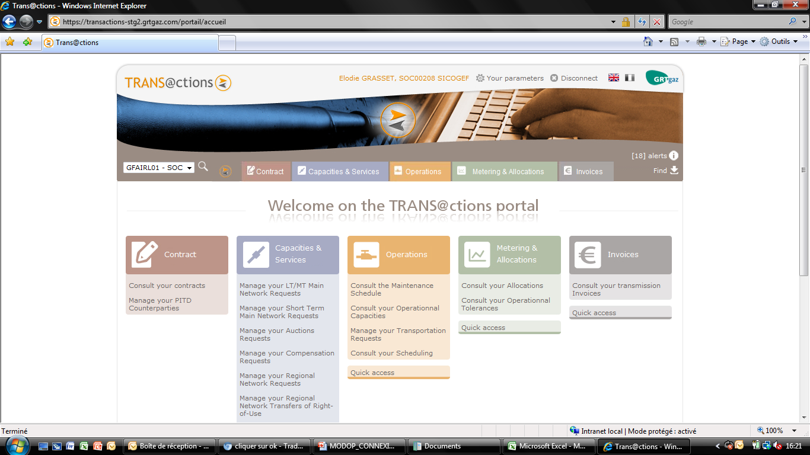

  - How to log out of the TRANS@ctions portal?
- To log out of the TRANS@ctions portal, simply click on the link “Disconnect” at the top right of the home page.

  - Are my publications still available on the ECT portal?
- The former ECT portal will still be running until the end of August in consultation mode, allowing you to visualise your publications prior to 24/05.

  - Are my publications still available in the ECT format?
- After the 24/05, publications will be available in the TRANS@ctions CSV format, as well as the ECT CSV format for the Provisional Metering Statement.

- Miscellaneous

  - How is the TRANS@ctions portal organised?
- The top bar is always visible and allows a quick access to :
  - User’s personal settings
  - Some functionalities of the main menu
  - The search for publication
  - The management of Alerts
Identity of the person connected

Access to parameters

Select language

Choice of available contracts

Return to home page

Main Menu

Quick access to Alerts management and Search

- The bottom bar on the home page gives you a quick access to the Maintenance Schedule, as well as to the Effective Temperatures of the three Balancing Zones :
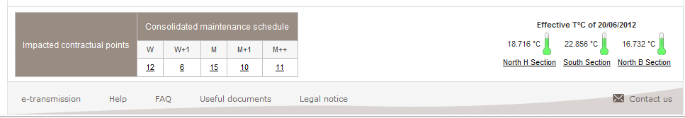
Daily Effective Temperatures

Extract of the Consolidated Maintenance Schedule

  - How can I modify my parameters?
- By clicking on the link “Your parameters” at the top of the home page, you will be able to modify some information about yourself:
  - Telephone number
  - Mobile telephone number
  - Fax
  - Email
  - Default contract (if you have access to more than one contract)
- In the « Parameters » page, you can also modify your Alerts. You can choose to receive your Alerts by fax, email, or only through the portal.

  - How to search for publications?
- You can search for publications in several ways:
  - By navigating through the drop-down menu
  - By clicking on the quick access links
  - By clicking on the link “Find” at the top of the home page.
- This FAQ explains in more detail how to search for a specific publication. Refer yourself to the summary to find out how to access to a publication in particular.

  - Under which formats are publications available?
- Publications are available in the following formats: XML, CSV
- Invoices are available in the following formats: PDF, CSV and XML

  - How can I consult the publications historic?
- Only the most recent publication of each type is available via the home page. Please use the link “Find” to search for earlier publications.
- The former portal ECT will still be available until the end of August in consultation mode to allow you to visualise publications prior to the 24/05.
- New publications will only be available on the TRANS@ctions portal.

  - How to subscribe or unsubscribe to Alerts?
- You can choose the Alerts you want to receive. To subscribe or unsubscribe to the different Alerts, click on «Your parameters» in the top bar and tick the Alerts you want.

  - I have counterparties at « NONE » in several publications, is this normal?
- If you have a counterparty at “NONE”, it only means that you have no counterparty on that Contractual Point.

  - If I want to download a publication for a Gas Day prior to the deployment of the portal, will it be available in the former or the new format?
- The former portal ECT will be available until the end of August in consultation mode to allow you to visualise publications prior to the 24/05.
- New publications will be available only on the TRANS@ctions portal.

- Capacities and Services

  - How are Capacities managed in TRANS@ctions?
- The TRANS@ction portal allows you to subscribe Capacity on the following points of the network:
  - Network Interconnection Points
  - North/South Link
  - H-gas to L-gas and L-gas to H-gas Conversion Points
  - Transmission-Production Interface Point
- NB : On Transmission-Storage Interface Points and Transmission-LNG Terminal Interface Points, GRTgaz applies an automatic Capacity Allocation. In the portal you can consult the Capacity that has been allocated.
- The TRANS@ction portal allows you also to track your Capacity transfers :
  - Full Capacity transfers
  - Transfers of right-of-use Capacity

Subscribing Capacity on the Upstream Network

    - How does the Medium Term/Long Term Capacity Request process work?
- A MT/LT Capacity request could be multi-annual, seasonal, annual, seasonal or monthly .
- The process for booking MT/LT Capacity in TRANS@ctions includes four steps :
  - Consulting commercialised and available Capacity
  - Searching for the corresponding Capacity Offer
  - Creating, Saving and Confirming your Capacity request
  - Tracking your request

    - How can I consult available Capacity ?
- Click on « Capacities & Services> Manage your LT/MT Main Network Request> Consult the Marketed Capacities » on the top bar menu or the homepage menu.
- These files are updated by GRTgaz at least 3 times a month.

How can I search for the corresponding Capacity offer ?
- Click on « Capacities & Services > Manage your LT/MT Main Network Request > Create a Capacity Request » on the top bar menu or the homepage menu.
- Offer coding principle:
  - Contractual Point Code
  - Flow direction
  - Type of Capacity (firm/interruptible)
  - Type of Subscription (annual/seasonal/monthly)

    - How can I create, save and confirm a MT/LT Capacity request?
- Drill down the Capacity offer by clicking on the « + ».
- The request can be a feasibility or a reservation.
- To save and confirm your request, Click on « Capacities & Services > Manage your LT/MT Main Network Request > Registrate your Capacity Requests ».
- Then click on « Capacities & Services > Manage your LT/MT Main Network Request > Validate your Capacity Requests » on the top bar menu or the homepage menu.
- Remember to save and confirm the request, because requests will only be processed by GRTgaz if they have been confirmed (i.e sent status).

    - How can I track my MT/LT Capacity request ?
- Click on « Capacities & Services > Manage your LT/MT Main Network Request > Create a Capacity Request » on the top bar menu or the homepage menu.
- Click on the reference of the request to display the details.

    - How does the request for Short Term Capacity process work?
- The process for a Short Term Capacity request in TRANS@ctions includes three steps :
  - Consulting available Capacity
  - Creating, Confirming and Tracking your Capacity request
  - Consulting the auction results if any.

    - How can I consult available Short Term Capacity ?
- Click on « Capacities & Services > Manage your Short Term Main Network Request > Consult The Short Term Available Capacities » on the top bar menu or the homepage menu.
- Click on the « Daily Capacity request » link to access directly to the Capacity request screen.

    - How can I create, confirm and track a Short Term Capacity request ?
- Click on « Capacities & Services > Manage your Short Term Main Network Request » or Capacities & Services > Manage your Auctions Requests » on the top bar menu or the homepage menu to get access to the creation and confirmation submenus of your ST Capacity request.
- The procedures are similar to those for MT/LT request.
- The main difference is that the request does not need to be registered, as it can be approved directly after initialisation.

    - How can I consult results and the auction price ?
- Click on « Capacities & Services > Manage your Auctions Requests > Consult The auction results » on the top bar menu or the homepage menu.
- You can export the results of an auction in a CSV file by clicking on the "Export .csv" button.

Capacity transfers

    - What is a full Capacity transfer ?
- In the case of a full transfer, all the rights and obligations relating to the transferred Capacity are transferred from the transferor to the transferee.
- The full rights and obligations being transferred, the full transfer impacts the level of subscribed Capacities of each shipper.
- The full Capacity transfers can be made via Capsquare or joint notification (e-mail then letter) to GRTgaz.
- In both cases, the Capacity acquired and transferred are updated and can be consulted via TRANS@ctions in the Services and Capacities Portfolio (PSC) menu.

    - How can I consult/download my acquired and/or transferred Capacities in the Services and Capacities Portfolio (PSC)?
- Click on « Capacities & Services > Consult your subscribed Capacities & Services > Consult your Services & Capacity Portolio D or M » on the top bar menu or the homepage menu, then click on the icon to display the details of your subscribed Capacities on the concerned point

How can I subscribe Capacity on the Downstream Network?

    - How does the Capacity request on a Consumer Delivery Point (LI) or a Regional Network Interconnection Point (PIRR) process work ?
- The process for Capacity request on LI/PIRR in TRANS@ctions includes three steps :
  - Searching for the corresponding Capacity Offer
  - Creating, Saving and Confirming your Capacity request
  - Tracking your request

    - How can I search for a Capacity offer ?
- Click on « Capacities & Services > Manage your Regional Network Requests > Create a Capacity Request » on the top bar menu or the homepage menu;
- Offer coding principle :
  - Contractual Point Code
  - Flow direction
  - Type of Capacity (firm/interruptible/empty)
  - Type of Subscription (annual/seasonal/monthly/daily)
- If you don't fill the "Capacity type" field on the regional network, you will create a single request for firm and interruptible Capacities.

    - How can I create, save and validate my request?
- The procedure is the same as for Upstream Network Requests.
- By clicking on "Monthly Services and Capacities Portfolio", you can consult the yearly and monthly Capacities that you have already subscribed on this point. As on the Upstream Network, you can make a feasibility request or a Reservation.
- NB: From now on, you must enter the extra Capacity you need, regardless the time step of your subscription.
  - If you have already subscribed the Capacity on this point and you want to change it to higher level of Capacity, you must enter a positive request.
  - Similarly, if you have already subscribed the Capacity on this point and you want to change it to lower this level of subscription, you must enter a negative request.

    - How can I track my Capacity request ?
- Click on « Capacities & Services > Manage your Regional Network Requests > Consult your Capacity Requests » on the top bar menu or the homepage menu.

    - What is a Right of Use Transfer (RoU)?
- During a Right of Use Transfer of downstream Capacities on a delivery point, the transferor shipper is allowed to transfer the Operational downstream Capacity, while keeping it in its contractual portfolio.
- The Right of Use Transfer covers at least a full month and must be entered in TRANS@ctions before the 15th of month M-1 to start the first of the month M.
- For the Right of Use Transfer on a Delivery Point, the whole Capacity on the dedicated point will be transferred (annual, monthly, daily, firm or interruptible) and any new subscription during the transfer period will automatically be transferred to the transferee. Re-transferring a transferred Capacity is not permitted.
- You can cancel a Right of Use (before starting) or interrupt (once started) by informing GRTgaz.

    - How can I create a Right of Use request ?
- Click on « Capacities & Services > Manage your Regional Network Transfer of Right-of-Use > Create a TRU Request » on the top bar menu or the homepage menu.
- The transfer involves the full Capacity subscribed at a point, therefore you simply enter the delivery point concerned.

    - How can I consult my Right of Use request ?
- Click « Capacities & Services > Manage your Regional Network Transfer of Right-of-Use > Consult your TRU Request » on the top bar menu or the homepage menu
- Once the request has been processed by GRTgaz, both Shippers are notified by a specific alert and both Shippers Portfolios are updated.

    - What is the Standardized Subscription principle?
- All Capacity subscribed on any PITD is allocated in a standardized way, whatever the subscription type (annual/monthly/daily), on the basis of the information sent by the Distribution System Operators.
- You don't need to make any Capacity request at these regional network's points, but send a joint declaration (i.e declare a Transmission Contract and a Distribution Transmission Contract active in one or more Distribution Points), so GRTgaz will automatically allocate Capacity on the basis of the DSOs data.

    - How can I create a Joint Declaration ?
- Click on « Contract > Manage your PITD Counterparties > Create a Joint Declaration » on the top bar menu or the homepage menu.
- Save your declaration once you have selected the PITD(s) and entered the starting and ending date.

    - How can I send my Joint Declaration to GRTgaz ?
- Click on « Contract > Manage your PITD Counterparties > Send your Joint Declarations » on the top bar menu or the homepage menu.

How to Subscribe to Services

    - What are the Services provided by GRTgaz ?
- Services provided by GRTgaz :
  - Access to the PEG
  - Subscription for Optional Contractual Tolerances
  - Short-Notice Reservation Offer
  - Test Phase Offer

    - How can I subscribe to get access to the PEG ?
- Click on « Capacities & Services > Subscribe to a Service > Subscribe to Access to Title Transfer Point » on the top bar menu or the homepage menu.

    - How can I Subscribe to Optional Balancing Tolerance ?
- This service allows you to increase your standard balancing tolerance up to 3% of your subscribed daily delivery Capacity.
- Click on « Capacities & Services > Subscribe to a Service > Subscribe to Optional Balancing Tolerance » on the top bar menu or the homepage menu.

    - How can I subscribe to reduced-notice offer?
- This service allows you to subscribe daily Capacity on a consumer delivery point with a short notice period.
- Click on « Capacities & Services > Subscribe to a Service > Subscribe to reduced-notice offer » on the top bar menu or the homepage menu.

    - How can I subscribe to Trial Offer ?
- This service allows you to use up to 10 days of daily delivery Capacity, depending on your needs over a month, with the possibility of changing the days of use retrospectively.
- Click on « Capacities & Services > Subscribe to a Service > Subscribe to Trial Offer » on the top bar menu or the homepage menu.

How to consult your Services and Capacities Portfolio (PSC)

    - What is the Services and Capacities Portfolio (PSC) ?
- This portfolio summarises in a single document :
  - the Capacities and services you have subscribed
  - your possible Capacity transfers or/and your Right-of-Use transfers
  - your Operational subscribed Capacity
  - in 3 sections (Upstream Network, Downstream Network, Services).
- The portfolio can be consulted in 2 different formats :
- The Daily PSC :
  - Aggregates the data gas day by gas day
  - Covers your Capacities and services subscribed on Months M-1, M, M+1
- The Monthly PSC :
  - Aggregates the data on a monthly basis
  - Covers your Capacities and services subscribed on Month M+2 to your last subscription
  - Also provides a valuation in Euros of the subscribed Capacity (valuation at the tariff which is in force when the PSC is generated).

    - How can I consult/download the PSC « live data » ?
- The PSC “live data” is available on the portal. These data are updated at each new capacities subscription.
- Click on « Capacities & Services > Consult your subscribed Capacites & Services > Consult your subscribed Services & Capacity Portfolio D or M » on the top bar menu or the homepage menu.

    - How can I consult/download a published PSC ?
- The Monthly PSC is updated every day around 8.30pm.
- The Daily PSC covering the month M+1 is updated around 9.00am
- The Daily PSC covering the month M is updated only if a new Capacity is subscribed.
- Access to publications is possible by clicking on the « Find » link on the top bar or by clicking on the « Consult publications » button of the PSC live data view screens.
- In addition, the PSC is updated:
  - The day after the subscription of a new Capacity for the Monthly PSC.
  - The hour following the subscription of a new Capacity for the Daily PSC.

- Operational Capacities, Nominations and Scheduling

Maintenance Schedule

    - What is the Maintenance Schedule ?
- The Consolidated Maintenance Schedule publication gives the following data:
  - The daily Restriction Data: CMXTt, CMNTt, CMXTi, CMNTi and CTE.
  - The daily restriction rates: Max TRf, Min TRf, Max TRi, Min TRi, TRf and TRi.
  - Firm technical capacity: CTNf
  - Subscribed firm and interruptible capacity: ΣCOSf and ΣCOSi
  - Fact sheets specifying the nature of the engineering work

    - How can I consult/download the Maintenance Schedule ?
- Click on « Operations > Consult the Maintenance » on the top bar menu or the homepage menu.
- Click on the « Search » button to display results.
- To access past Restriction Data, click on the Gas Day.
- To access the details of a fact sheet, click on the publication notice reference.
- To access the Operational Capacity Summary, click on the « Operational Capacity Summary » link at the bottom of the page.
- When the page opens, you see only columns TRf, Tri and CTE.
- When you click on the « + » buttons attached to those columns, you see the min and max for the Restriction Rates and Restriction Data.

    - What are the new definitions of Restriction Data?

TRANS@ctions name | Definition
CTNf | Firm Nominal Technical Capacity. It corresponds  to the physical capacity associated with a  Contractual Point defining firm Saleable Capacity
CMNTt | Technical Minimum Capacity available in the  event of engineering works.
CMXTt | Technical Maximum Capacity available in the  event of engineering works.
CMNTi | Minimum Technical Capacity including available  interruptible capacity (F+I).
CMXTi | Maximum Technical Capacity including available  interruptible capacity (F+I).
CTE | It is the actual total technical capacity on a PCR  that GRTgaz can actually guarantee to all  Shippers per Gas Day. It can differ from CTN in  the event of restrictions.
ΣCOSf / ΣCOSi | Subscribed Firm / Interruptible capacity by all  shippers for a day.

How can I consult my Operational Capacities ?

    - How can I consult the summary of Operational Capacity ?
- Click on « Operations > Consult your Operational capacities > Consult your Operational capacities » on the top bar menu or the homepage menu.
- In the search screen, two types of searches are possible :
  - Either a single gasday as search criteria
  - Or several criterias : a contractual point type and/or a contractual point and/or a direction and a period.

    - How can I consult/download my Notice, Statement and Schedule of Operational Capacity?
- Click on « Find » on the top bar and choose the type of publication.
- It contains the following data :
  - The most recent Transmission requests by the shipper
  - The Subscribed Operational Capacity
  - The restriction rates
  - The actual Operational Capacity
  - The Allocated Operational Capacity, guaranteed COA & planned COA
  - UIOLI D (“within rights”) and HD (“without rights”) capacity, which correspond to the parts assigned with and without rights (CU D & CU HD), where “CU” refers to “UIOLI Capacity”.
  - Available UIOLI capacity

Nominations and Scheduling

    - What is a Transmission request ?
- A Transmission request includes :
  - A Point
  - A Counterparty
  - A Direction
  - Energy (kW 25°C)
- Each new Transmission request replaces the previous one
- The setting of new counterparties is made directly via the portal
- The Transmission request on the portal are signed :
  - Nomination Entry Network: positive
  - Nomination Exit Network: negative
- Forecasts :
  - No time constraints
  - Possibility of sending Transmission requests up to 6 months in advance
  - If a daily Transmission request is missing, forecasts are used as Transmission requests

    - How can I create a Transmission request ?
- Click on « Operations > Manage your Transmission requests » on the top bar menu or the homepage. Then, you can make a manual input for each contractual point or Upload a batch file (.csv)
- Uploading a file of Transmission requests :
  - Click on «Operations > Manage your Transmission requests > Creation of a batch of Transmission requests» on the top bar menu or the homepage.
  - The file format must be CSV.
- Manual input of Transmission requests :
  - You can select the contractual point type and the gas days for which you want to make a request.
  - Click on the « Search » button to access the list of contractual point related to the selected type and tick the points you want to nominate on.
- Entering a Transmission request :
  - The screen below displays the Transmission requests by contractual point, counterparty and gas day.
  - The upper part of the screen summarizes the imbalance due to the last Transmission requests. The data are displayed by zone and gas day.
  - At any time, you can recalculate these imbalances by clicking the « Refresh » button.
  - The modified Transmission requests are highlighted in green.
  - Tick the rows that you want to take into account and confirm by clicking the « Confirm batch input » button.
- Add a new counterparty :
  - To enter a Transmission request, you have to modify the "Quantity" column.
  - Click the « Add a Counterparty/Direction pair to this Contractual Point » link to add a new counterparty
- Consulting the direction : the quantities must be signed according to the principle below :
  - Transmission request in Reception (REC): Entering a positive Transmission request
  - Transmission request in Delivery (DEL): Entering a negative Transmission request
- If the sign is inconsistent with the direction of the transmission request, an error message is displayed and the request is reset to 0 in the input screen.

    - How can I consult my Transmission requests ?
- Click on « Operations > Consult your Transmission Request Batches » on the top bar menu or the homepage
- A search screen then allows you to access the batch of transmission requests according to several criterias:
  - The channel (Edig@s, File upload on the portal, Manual input on the portal)
  - The status (Accepted, Rejected)
  - The batch generation period
  - The gas day contained in the batch
- Click the batch number to access :
  - The reason for rejection if the batch is rejected
  - The transmission requests of the batch if the batch is accepted

    - I have made a Transmission request on the TRANS@ctions portal, has it been taken into account?
- You can consult directly on the portal TRANS@ctions: by clicking on « Operations > Manage your Transmission Requests > Consult your Transmission Requests »
- Search for your Transmission request to see if your request has been accepted.
- If the request has been denied, the reason of the refusal appears on your screen.

    - I have made a Transmission request on Edig@s, has it been taken into account ?
- You can consult directly on the portal TRANS@ctions: by clicking on « Operations > Manage your Transmission Requests > Consult your Transmission Requests » to see if your request has been accepted.

    - Do we need to put a negative value when Nominating in Delivery ?
- Yes, you need to use a minus sign (-) if you Nominate in Delivery. Nevertheless, only nominate in absolute value on Edig@s.
    - How can I consult available UIOLI ?
- Click on « Operations > Consult the UIOLI Offer » on the top bar menu or the homepage.
- Select the gas day and click the « Search » button. The UIOLI offer is displayed by contractual point
- The UIOLI capacity allocated is available on the Operational Capacities Statement.

    - How can I consult/download the publication of Partial Confirmation Notice?
- Confirmation on the PEGs is done by the publication of a Partial Confirmation Notice in the first 15 minutes of each processing cycle. It makes available the programming data on the PEGs.
- Access to that publication is possible by clicking the « Find » link on the top bar.

    - How can I consult/download my Confirmation Notice ?
- Click on « Operations > Consult your Scheduling > Consult your Confirmation Notice D (or D+1) » on the top bar menu or the homepage.
- Then you can access to latest confirmation notice of the selected gas day (D or D+1).
- Scheduled quantities by contractual point are grouped per balancing perimeter. For each perimeter, the imbalance of latest transmission requests and scheduled quantities are reported.
- In case of a mismatch the "Variation" box column are displayed in red.
- Historical scheduled Quantity is published since the first cycle of the gas day. The shipper can access it by clicking on the contractual point.
- By clicking on the scheduled Quantity you can access the reason for capping if any.

    - I cannot see my Confirmation Notice.
- If you haven’t subscribed for any Quantity, the Confirmation Notice is not published.

Specific questions regarding the management of Operational Capacities, Nominations and Scheduling

    - When I consult the Maintenance Schedule, how can I know to which Contractual Point corresponds a given Point Code?
- When you want to view the Consolidated Maintenance Schedule, you can set as a criterion for viewing the type of Contractual Point and the Contractual Point. For the Contractual Point, the selection is done by Point Code (for example BH0001, HB0002, NS0001, etc).
- The wording of a Contractual Point appears in the results. For example, for PCR IR0011, the wording "Oltingue" will appear.

    - Did some types of Contractual Points change with the switchover from ECT to TRANS@ctions?
- Yes, the points affected by this change are listed below:
  - NS0001 (North-South Link)
  - IR0012/IR0022 (peak conversion H-gas to L-gas)
  - IR0026/IR0027 (conversion L-gas to H-gas)
  - TI0601 (basic service conversion H-gas to L-gas).
- The names of these points have changed:
  - NS0001/NS0002 = NS0001 (North-South link)
  - IR0012/IR0022 = HB0002 (Peak conversion – H to L)
  - IR0026/IR0027 = BH0001 (Conversion – L to H)
  - TI0601 = HB0001 (Basic Service Conversion - H to L)
- If the direction of the gas flow is DEL, then the Quantity of gas is negative. If the direction of the gas flow is REC, then the Quantity of gas is positive.

- Metering and Allocations

Measurements

    - How does the Metering process work?
- Measurements are the quantities arising from metering or estimate on the PCE. They are published on the PLC and PLCd.
- Customer industrial measurements are viewable by his supplier if the customer has given him an official permission to view them.
- They are integrated into the TRANS@ctions system and can be consulted on the portal through the following documents:
  - Intraday measurements
  - Measurement notices
  - Measurement Statements (Provisional/Definitive/Adjusted)

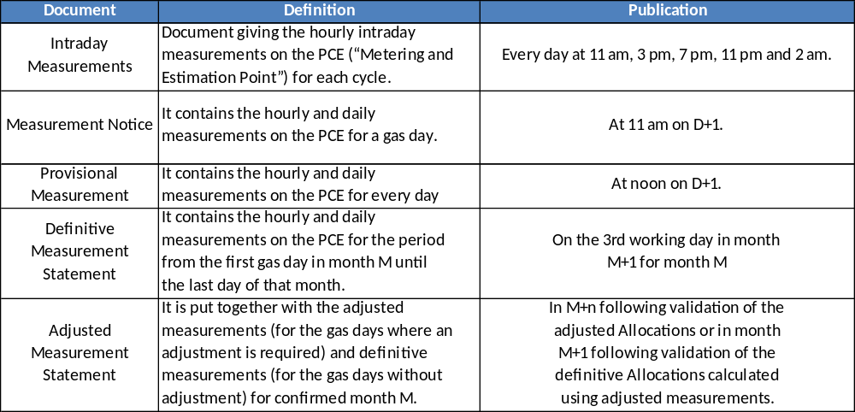

    - How can I consult/download my Intraday Measurements ?
- Click on « Metering & Allocations > Consult your Metering > Consult your Within-Day Metering Notice » on the top bar menu or the homepage menu.
- The latest publication is displayed.
- The publication contains all of the metering points according to your authorizations.
- Click on the “Delivered Quantity” of a metering point to access details of hourly measurements in the gas day.
- Older publications are available in the Search module (top right of the home page).

    - How can I consult/download my Measurements notice ?
- Click on « Metering & Allocations > Consult your Metering > Consult your Metering Notice » on the top bar menu or the homepage menu.
- The latest publication is displayed.
- The publication contains all the metering points according to your authorizations.
- Click on the “Delivered Quantity” of a metering point to access the characteristics of the daily measurements.
- Click on the “Delivered energy quantities” to access the details of the hourly measurements in the gas day.
- Older publications are available in the Search module (top right of the home page).

    - How can I consult/download my Provisional Measurements Statement ?
- Click on « Metering & Allocations > Consult your Metering > Consult your Metering Statement » on the top bar menu or the homepage menu.
- The latest publication is displayed.
- The publication contains all the metering points according to your authorizations.
- Click on the “Delivered quantities” to access the details of the measurements for a gas month.
- Click on the “Gas Day” to access the characteristics of the daily measurements.
- Click on the “Delivered energy quantities” to access the details of the hourly measurements in the gas day.
- You will always find the current month’s notice through the menu. Older publications are available in the Search module (top right of the home page).

    - How can I consult/download my Definitive Measurements Statement ?
- To access this publication, click on « Find » on the top bar of the home page.
- The publication contains all the metering points according to your authorizations.
- Click on the “Delivered quantities” to access the details of the measurements for a gas month.
- Click on the “Gas Day” to access the characteristics of the daily measurements.
- Click on the “Delivered energy quantities” to access the details of the hourly measurements in the gas day.

    - How can I consult/download my Adjusted Measurements Statement ?
- To access this publication, click on « Find » on the top bar of the home page.
- The publication contains all the metering points according to your authorizations.
- Click on the “Delivered quantities” to access the details of the measurements for a gas month.
- Click on the “Gas Day” to access the characteristics of the daily measurements.
- Click on the “Delivered energy quantities” to access the details of the hourly measurements in the gas day.

  - How does the Allocations and Balancing process work ?
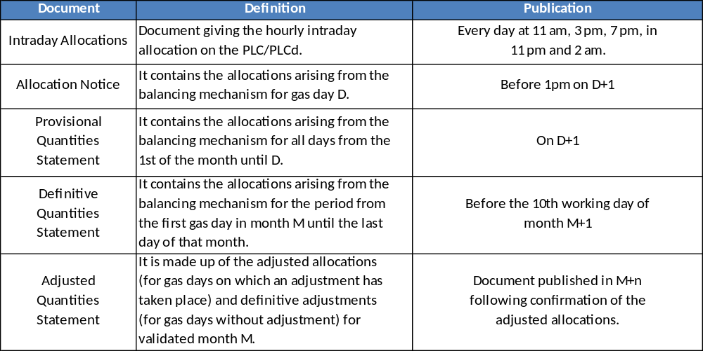

    - How can I consult/download my Intraday Allocations ?
- Click on « Metering & Allocations > Consult your Allocations > Consult your Within-Day Allocation Notice » on the top bar menu or the homepage menu.
- The latest publication is displayed.
- The publication contains all the PLC/PLCd according to your authorizations.
- Click on the “Delivered pool/point” to access the details of the hourly consumptions of the point.
- Older publications are available in the Search module (top right of the home page).

    - How can I consult/download my Allocation notice ?
- Click on « Metering & Allocations > Consult your Allocations > Consult your Allocation Notice » on the top bar menu or the homepage menu.
- The latest publication is displayed.
- The quantities are classified per perimeter (North-B zone, North-H zone and South zone) then per category, PCR and direction.
- If the allocation is different from the confirmation then it appears in red (this may be the case for a Delivered pool).
- Click on the Code of a Contractual Point to view the details of the Contractual Point by counterparty.
- Click on the arrow to view the details of the contractual point under the delivery point.
- Older publications are available in the Search module (top right of the home page).

    - How can I consult/download my Provisional Quantity Statement?
- To consult the Quantity Statement, click on « Metering & Allocations > Consult your Allocations > Consult your Quantity Statement » on the top bar menu or the homepage menu.
- Click on the « Find » link on the top bar of the home page to consult the other Quantity Statements : Definitive, Adjusted and Provisional (for the M-1 month, before validation).
- The first array summarizes imbalances per perimeter:
  - You can access to details by date or by counterparty by clicking on a perimeter.
  - Then, when clicking on the contractual point, you will be able to see the details by date or by counterparty.
- You will always find the current’s month notice through the menu. Older publications are available in the Search module (top right of the home page).

    - How can I consult/download my Monitoring Statement ?
- To consult the CEA monitoring Statement, click on « Metering & Allocations > Consult your Allocations > Consult your CEA Monitoring Statement » on the top bar menu or the homepage menu.
- The latest publication is displayed.
- Older publications are available in the Search module (top right of the home page).

  - Overruns

    - How does the Capacity Overruns process work ?
- Capacity overruns are available on the portal through the: “Capacity Overruns Statement” publication type.
Publication | Definition
Provisional Capacity  Overruns Statement | Published on D+1 at 1pm for the current month  Contains for the 1st gas day of the month to D :  - Provisional overruns  - Provisional allocation  - Operational Subscribed Capacities
Definitive Capacity  Overruns Statement | Published :  - Around the 4th working day of month M+1 for LI  - Around the 10th working day of month M+1 for PITD  Contains for the gas month :  - Definitive overruns  - Definitive allocation  - Operational Subscribed Capacities
Adjusted Capacity  Overruns Statement | Published after validation of the adjusted allocations on M+n.  Contains for the M month :  - Adjusted and Definitive overruns  - Adjusted and Definitive allocation  - Operational Subscribed Capacities

- TRANS@ction calculates daily and hourly capacity overruns.
- Daily capacity overruns are calculated on :
  - Exit from the Main Network
  - Transmission on the Regional Network
  - Delivery on the Regional Network
- Hourly capacity overruns are calculated on :
  - Transmission on the Regional Network
  - Delivery
- There is an overrun when the difference between the allocation and the subscribed capacity is greater than the subscribed capacity.
    - How can I consult/download my Capacity Overruns Statement ?
- Click on « Metering & Allocations > Consult your Allocations > Consult your Capacity Overruns Statement » on the top bar menu or the homepage menu.
- The latest published Capacity overruns Statement is displayed.
- You can download the publication in XML and CSV format. You can also access it directly on the portal.
- The daily and hourly overruns are indicated by a yellow pictogram if their status are provisional and by a red pictogram if their status are definitive or adjusted.
- Click on the Contractual Point to access the daily capacity overruns
- Click on the Gas Day Point to access the hourly capacity overruns

  - How to consult your Tolerances?

    - How can I consult Effective temperatures ?
- Effective temperatures of the day are visible on the bottom bar of the homepage.
- To consult the effective temperatures for a period, click on « Metering & Allocations > Consult your Operational Tolerances > Consult the Effective Temperatures » on the top bar menu or the homepage menu.

    - How can I consult/download my Maximum Imbalances Statement ?
- The balancing variables can be consulted in the maximum imbalances Statement:
  - The provisional maximum imbalances Statement is daily updated at 10:30 am.
  - The definitive maximum imbalances Statement is published before the 10th working day of the M+1 month.
- Click on « Metering & Allocations > Consult your Operational Tolerances > Consult your Maximum Imbalances Statement » on the top bar menu or the homepage menu.

  - Specific questions regarding the management of Allocations

    - A PCE is missing in my Metering Statement.
- This means that your industrial customer didn’t give you the permission to view the measures of that PCE in particular. If you want to view these measures, you will need to contact your client so that he can allow you.

    - I cannot download the Definitive Metering Statements for the month of April and the previous months.
- It is not possible to download the Definitive Metering Statement of April and previous months on the TRANS@ctions portal. You can get it directly on the ECT portal.
- The former ECT portal will still be running until the end of August in consultation mode, allowing you to visualise your publications prior to 24/05.

    - The Metering Statements (Provisional, Definitive and Adjusted) can be downloaded both in the CSV TRANS@ctions format and the CSV ECT format. Are they strictly identical?
- No. The Metering Statements available in the CSV ECT format only include daily data. If you want the hourly data, you will need to consult the Metering Statements in the CSV TRANS@ctions format.
    - I cannot see my Allocation Notice.
- If you are unable to see your Allocation Notice, this means you haven’t programmed any Quantities.

    - Intraday Allocations : does a consumption beginning with the time 6:00 correspond to the consumption of the portion from 6am to 7am?
- Yes. If a consumption begins at 6:00, it corresponds to the consumption of the portion from 6:00am to 7:00am. If a consumption begins by 8:00, it corresponds to the portion between 8:00am and 9:00am, and so on.

    - I have downloaded the new Metering Statement (CSV TRANS@ctions format) and I have noticed differences compared with the former Metering Statement (CSV ECT format). Are there any differences between the two publications ?
- Yes: a new “Quality gas” data has been added in the new TRANS@ctions format.

    - What are the differences between a Metering Statement and a Quantity Statement ?
- The Metering Statement is a publication reporting Measured Quantities for each PCE attached to a consumer.
- The Quantity Statement is a new publication. It replaces two old publications that are not available anymore in TRANS@ctions: the Confirmation Statement and the Allocations Statement.
- The Quantity Statement is a more detailled publication which allows to visualise Allocated Quantities at the PCR and Balancing data.

    - Why am I unable to see my Allocations on last month’s Invoice ?
- GRTgaz charges Subscribed Capacities of the billable month (M-1) and Allocations of the previous month (M-2). On your bill, you will see your Allocations for the month (M-2).
- Example: In the month of March, you receive an Invoice for the month of February:
  - Subscribed Capacities charged: those of February.
  - Allocations charged: those of January.

- Invoices

  - How to consult my last invoice ?
- To access latest published invoice, click on « Invoices » on the top bar menu or the homepage menu.
- The invoice for a M month includes :
  - Terms of capacity for M
  - Terms of quantities for M-1
  - UIOLI for M-1
- Attached documents are :
  - Your invoice
  - Your record of purchase
  - Possible explanatory notes for patches
  - The amendment invoice if a Quantity or a capacity has been modified and the related invoice Statement
- You can export the invoices and the related documents in PDF, XML and CSV format.

  - How to consult older invoices ?
- Older invoices are available in the Search module (top right).

- Definitions

  - What is a Metering and Estimation Point (PCE) ?
- Point on GRTgaz’s Network where the energy of a Quantity of gas taken off or delivered each day or each hour is measured or estimated. This Quantity can be estimated, measured or calculated by a linear combination of other PCEs.

  - What is a Contractual Point (PCR) ?
- Generic point used as a contractual basis for subscribing Capacity, nominating Quantities, calculating Allocations:
  - Title Transfer Point (PEG): Virtual point at which the Shipper may deliver quantities of Gas to another shipper, or receive Gas delivered by another Shipper. A Title Transfer Point is associated with a Balancing Zone. Other terms used are Hub or Marketplace.
  - Transmission- Storage Interface Point (PITS) : Delivery Point where the Recipient is the Operator of the storage facility (facilities) located downstream of that point. A Transmission-Storage Interface Point can also be an Entry Point.
  - Regional Network Interconnection Point (PIRR) : Delivery Point located on the regional transmission network where the Recipient is the Operator of the transmission network located downstream of that point. A Regional Network Interconnection Point is associated with a single Exit Zone.
  - Network Interconnection Point (PIR): Contractual point at the interface between GRTgaz and an adjacent Transmission System Operator.
  - Consumer Delivery Point (PLC or LI): A Consumer Delivery Point is a Connection Facility that supplies an End Customer. Except where expressly stated otherwise, a Consumer Delivery Point is situated at the downstream flange of a Delivery Station. A Consumer Delivery Point is associated with a single Exit Zone.

  - What is the link between a PCE and a PCR ?
- A Quantity is measured or estimated at a PCE. Quantities measured or estimated are recovered and are integrated into TRANS@ctions.
- The Quantities measured or estimated are aggregated by Contractual Point (PCR) to obtain the aggregated Quantities by PCR.

