

Allocation notice

This document describes the exchange format of data linked to the Allocation Notice, abbreviated as AVR.

Monitoring of the Versions

|  |  |  |  |
| --- | --- | --- | --- |
| Version | Date | Author (s) | Description |
| V3.2 – V0.1 | 12/02/2013 | R. Andrieux | Consideration of the evolution 11829 « coefficient k0 » coefficient k0 |
| V3.2 – V1.0 | 25/02/2013 | F. Guingal | Consideration of comments on DE 11829 :   * N° 12 to 15 |
| [T@V5.0](mailto:T@V5.0) – V1.1 | 05/09/2014 | E. Denamiel | Consideration of comments on DE S140613_000030 |
| [T@V5.0](mailto:T@V5.0) – V1.2 | 08/09/2014 | E. Denamiel | Consideration of comments on DE S140613_000030 |
| V5.0 – V2.0 | 29/08/2014 | F. Guingal | Consideration of DE S140530_000066 : addition of EBJ trading region |
| V5.0 – V2.1 | 12/09/2014 | E. Denamiel | Consideration of reports V5.0 lot A1 |
| V5.2 – 1.0 | 18/06/2015 | P. Deleplanque | Consideration of the DE S150529_000011 |
| V5.2 – 1.1 | 26/06/2015 | P. Deleplanque | Consideration of GT remarks |
| V5.2 – 1.2 | 27/07/2015 | E. Denamiel | Consideration of GT remarks |
| V5.2 – 1.3 | 29/07/2015 | E. Denamiel | Consideration of GT remarks |
| V9.0– 1.0 | 12/06/2018 | C. David | Consideration of Zefir modifications on the GT |
| V9.0 – 1.1 | 05/07/2018 | O. Keith | Consideration of GT remarks |
| V9.0 – 1.2 | 27/07/2018 | C. David | Updation of the sample csv and xml files |
| V9.0 – 1.3 | 27/07/2018 | C. David | Updation of the xsd file template |
| V10.0 – V1.0 | 14/11/2018 | L. Cordelle | Consideration of the EG_EQUI_088 |
| V11.1 – V1.0 | 13/02/2020 | M. EL MAARABANI | Update of the CSV and XML publications to flag the backup quantities |

# File definition

The allocations notice provides the details of daily allocations and imbalances of the gas day D.

It also contains the last daily forecast by shippers of tele-declared consumption distribution of non-profiled clients on the balancing section.

It is published on D + 1 once the TRF imbalance has been calculated.

# Localization of the document

The Allocations Notice file is downloadable on the TRANS@ctions portal via the page of publications searching:

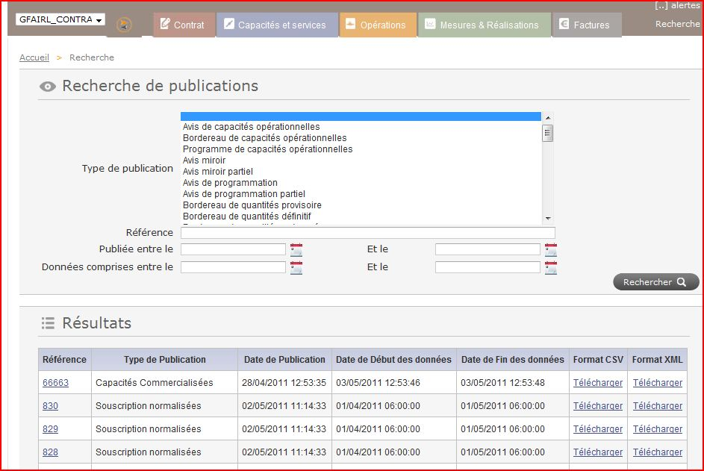

Finally, the allocations notice is available via Beesquare in B2B flows.

# Name and format of the file

The file published is in .CSV and .XML format.

It will be named according to the following rule:

|  |  |  |  |  |
| --- | --- | --- | --- | --- |
| **N°** | **Name** | **Type** | **Length** | **Format** |
| 1 | Exchange Type | Alphanumeric | 3 | AVR |
| 2 | Contract Code | Alphanumeric |  |  |
| 3 | Date | Date | 14 | JJMMAAAAhhmmss / DDMMYYYYhhmmss |
| 4 | Extension | Alphanumeric | 4 | .csv or .xml |
| 5 | Separators |  | 4 | « _ » |

Finally the files have therefore full name:

AVR_CODECONTRAT_JJMMAAAAhhmmss.csv

AVR_CODECONTRAT_JJMMAAAAhhmmss.xml

# Description of the file

## CSV Format

The tables presented in this section contain the following columns:

* N°: number of the field in the line
* Nom (Name): description of the contents of the field
* Type: type of the field
* Longueur (Length)
* Unité (Unit)
* Format: format of the data
* Obligatoire (Required) : Determine whether the field is mandatory to be filled or not ; if the field is not filled it is empty
* Valeur (Value): range of possible values ​​of the data or examples of values.
* Commentaire (Comment): extra precision.

In the following tables, the data types are following:

* N: digital
* X, AN: alpha-numeric
* D: date
* H: hour
* E: enumeration on 1 character.

The length is expressed in parentheses if necessary:

* X (n) is a string of n alphanumeric characters,
* 9 (n) is a string of n numerical characters,
* S9 (n) is a signed numeric string (+ or -).

The decimal separator is represented by a point.

| **N°** | **Name** | **Type** | **Length.** | **Unit** | **Format** | **Oblig.** | **Examples** | **Comment** |
| --- | --- | --- | --- | --- | --- | --- | --- | --- |
| **Header of services data (1 line per part)** | | | | | | | | |
| **1** | Avis de Réalisation / Allocation Notice : | AN | X |  | LIBELLE_FLUX_FR / LIBELLE_FLUX_EN : CODE_FLUX-x | O | Avis de Réalisation / Allocation Notice : AVR-920097 | AVR-X  Where X represents the identifier of the publication on File Platform |
| **2** | Réseau / Network | AN | X |  | Text | O | Réseau / Network : GRTgaz | Constant |
| **3** | Période / Period | D | X |  | DD/MM/YYYY hh:mm – DD/MM/YYYY hh:mm | O | Période / Period : 01/07/2010 06:00 – 02/07/2010 06:00 | Start date and end date of publication |
| **4** | ID contrat / ID contract | AN | X |  | Text | O | ID contrat / ID contract : GFxxxx01 | GRTgaz reference of the contract |
| **5** | ID expéditeur / ID shipper | AN | X |  | Text | O | ID expéditeur / ID shipper : GFxxxx | GRTgaz identifier of the shipper |
| **6** | Nom de l’expéditeur / Name of the shipper | AN | X |  | Text | O | Nom de l’expéditeur / Name of the shipper : YYYY | Name of the shipper |
| **7** | Date de mise à jour / Last update | D | X | Date | DD/MM/YYYY hh:mm:ss | O | Date de mise à jour / Last update : 17/07/2010 15:54:12 | Creation date of the file |
| **Section Perimeter (1 line with the label of the various columns, separated by semicolons;** **then 1 line by gas day/perimeter)** | | | | | | | | |
| **1** | Journée gazière / Gasday | AN | X | Date | DD/MM/YYYY | O | Ex : 17/07/2010 | gas day |
| **2** | Périmètre d'Equilibrage / Balancing Section | AN | X |  | Text | O | GRTgaz  GRTgaz B | Balancing section |
| **3** | Ecart de bilan demandé (kWh à 25°C) / Requested imbalance (kWh at 25°C) | N | 9 | kWh 25°C | Signed integer | N |  | Quantity of imbalance requested on the contract for the gas day on the section  This column is no more updated as from the date of deletion of balancing tolerances (that is, 1st October 2015). |
| **4** | Ecart de bilan demandé (kWh à 0°C) / Requested imbalance (kWh at 0°C) | N | 9 | kWh 0°C | Signed decimal | N |  | Quantity of imbalance requested on the contract for the gas day on the section  This column is no more updated as from the date of deletion of balancing tolerances (that is, 1st October 2015). |
| **5** | Ecart de bilan programmé GRTgaz (kWh à 25°C) / Imbalance confirmed by GRTgaz (kWh at 25°C) | N | 9 | kWh 25°C | Signed integer | N |  | Quantity of imbalance scheduled on the contract for the gas day on the section  This column is no more updated as from the date of deletion of balancing tolerances (that is, 1st October 2015). |
| **6** | Ecart de bilan programmé GRTgaz (kWh à 0°C) / Imbalance confirmed by GRTgaz (kWh at 0°C) | N | 9 | kWh 0°C | Signed decimal | N |  | Quantity of imbalance scheduled on the contract for the gas day on the section  This column is no more updated as from the date of deletion of balancing tolerances (that is, 1st October 2015). |
| **7** | Ecart de bilan de la trading region en fin de journée (kWh à 25°C)/) / Imbalance (kWh at 25°C) | N | 9 | kWh 25°C | Signed integer | N |  | Quantity of imbalance at the end of the day on the contract for the JG on the trading region linked to perimeter.  This column is not updated for GRTgaz B. |
| **8** | Ecart de bilan de la trading region en fin de journée (kWh à 0°C) / Imbalance (kWh at 0°C) | N | 9 | kWh 0°C | Signed decimal | N |  | Quantity of imbalance at the end of the day on the contract for the JG on the trading region linked to perimeter  This column is not updated for GRTgaz B. |
| **9** | Ecart de bilan en fin de journée (kWh à 25°C)/Imbalance (kWh at 25°C) | N | 9 | kWh 25°C | Signed integer | N |  | Quantity of imbalance of day on the contract for JG on the perimeter |
| **10** | Ecart de bilan en fin de journée (kWh à 0°C) / Imbalance (kWh at 0°C) | N | 9 | kWh 0°C | Signed decimal | N |  | Quantity of imbalance of day on the contract for JG on the perimeter |
| **11** | Ecart de bilan cumulé en fin de journée (kWh à 25°C) / Cumulative imbalance (kWh at 25°C) | N | 9 | kWh 25°C | Signed integer | N |  | Quantity of cumulated imbalance at the end of the day present on the contract for the gas day on the section  This column is not developed any more following the removal of the mid-range (i.e. for JG greater than or equal to 1st April 2015)) |
| **12** | Ecart de bilan cumulé en fin de journée (kWh à 0°C) / Cumulative imbalance (kWh at 0°C) | N | 9 | kWh 0°C | Signed decimal | N |  | Quantity of cumulated imbalance at end of the day present on the contract for the gas day on the section  This column is not developed any more following the removal of the mid-range (i.e. for the higher or equal gas days to DATE_BASCULE_TALON) |
| **13** | Quantités exposées à P1 (kWh à 25°C) / Quantities subjected to P1 (kWh at 25°C) | N | 9 | kWh 25°C | Signed integer | N |  | Quantities subjected to P1 present on the contract for the gas day on the section  This column is no more updated as from the date of deletion of balancing tolerances (that is, 1st October 2015). |
| **14** | Quantités exposées à P1 (kWh à 0°C) / Quantities subjected to P1 (kWh at 0°C) | N | 9 | kWh 0°C | Signed decimal | N |  | Quantities subjected to P1 present on the contract for the gas day on the section  This column is no more updated as from the date of deletion of balancing tolerances (that is, 1st October 2015). |
| **15** | Quantités exposées à P2 (kWh à 25°C) / Quantities subjected to P2 (kWh at 25°C) | N | 9 | kWh 25°C | Signed integer | N |  | Quantities subjected to P2 present on the contract for the gas day on the section  This column is not updated for GRTgaz B. |
| **16** | Quantités exposées à P2 (kWh à 0°C) / Quantities subjected to P2 (kWh at 0°C) | N | 9 | kWh 0°C | Signed decimal | N |  | Quantities subjected to P2 present on the contract for the gas day on the section  This column is not updated for GRTgaz B. |
| **17** | Quantités en dépassement d'EBCmax (kWh à 25°C) / Cumulative overbalancing (kWh at 25°C) | N | 9 | kWh 25°C | Signed integer | N |  | Quantities subjected to P3 present on the contract for the gas day on the section  This column is not developed any more following the removal of the mid-range (i.e. for JG greater than or equal to 1st April 2015) |
| **18** | Quantités en dépassement d'EBCmax (kWh à 0°C) / Cumulative overbalancing (kWh at 0°C) | N | 9 | kWh 0°C | Signed decimal | N |  | Quantities subjected to P3 present on the contract for the gas day on the section  This column is not developed any more following the removal of the mid-range (i.e. for higher or equal gas days to DATE_BASCULE_TALON) |
| 19 | Quantités exposées à P4 (kWh à 25°C) / Quantities subjected to P4 (kWh at 25°C) | N | 9 | kWh 25°C | Signed integer | N |  | Quantities subjected to P4 present on the contract for the JG on the section in kWh 25°C  This column is no more valued as from the date of deletion of balancing tolerances (that is, 1st October 2015) and is not updated for GRTgaz B |
| 20 | Quantités exposées à P4 (kWh à 0°C) / Quantities subjected to P4 (kWh at 0°C) | N | 9 | kWh 0°C | Signed decimal | N |  | Quantities subjected to P4 present on the contract for the JG on the section in kWh 25°C  This column is no more valued as from the date of deletion of balancing tolerances (that is, 1st October 2015) and is not updated for GRTgaz B.. |
| **Section Nomination (1 line with the label of the various columns, separated by semicolons;** **then 1 line by gas day//** **Network Contractual Point /directions/contreparts)** | | | | | | | | |
| **1** | Journée gazière / Gasday | AN | X | Date | DD/MM/YYYY | O | Ex: 7/17/2010 | gas day |
| **2** | Périmètre d'Equilibrage / Balancing Section | AN | X |  | Text | O | GRTgaz | Balancing section |
| **3** | Groupe de publication/Publication group | AN | X |  | Text | O | Ex : Point d'entrée  Point de sortie  Point de livraison… | The list quoted in example is non-exhaustive and can be set to change |
| **4** | ID point contrat/ID service point | AN | X |  | Text | O | PL001F | The contractual point code |
| **5** | Type de PCR / PCR type | AN | X |  | Text | O | Ex : PLC, PITD, PL | Type of the contractual point. |
| **6** | Libellé / Label | AN | X |  | Text | O | POOL DE LIVRAISON TRF | The wording of the contractual point |
| **7** | PCS / Realised GCV | N | 9 |  | Decimal | N |  | Daily Higher Heating value (at the PLC (Point de Livraison Consommateur/ Consumer Delivery Point) and PLCd (Point de Livraison Consommateur déclaré/ Declared Consumer Delivery Points only)) |
| **8** | Méthode / Calculation method | AN | X |  | Text | N | Ex : MESURE, DEMANDE, OBA | Calculation method of the allocations  The list quoted in example is non-exhaustive and can be set to change |
| **9** | Sens / Direction | AN | X |  | Text | O | Rec, Del | Direction of the contractual point |
| **10** | Contrepartie / Counterpart | AN | X |  | Text | N |  | Counterpart associated with the nomination |
| **11** | Qté demandée (kWh à 25°C) / Requested Qty (kWh at 25°C) | N | 9 | kWh 25°C | Signed integer | N |  | Requested quantity by the shipper |
| **12** | Qté demandée (kWh à 0°C) / Requested qty (kWh at 0°C) | N | 9 | kWh 0°C | Signed decimal | N |  | Requested quantity by the shipper |
| **13** | Qté programmée GRTgaz (kWh à 25°C) / Qty confirmed by GRTgaz (kWh at 25°C) | N | 9 | kWh 25°C | Signed integer | N |  | scheduled Quantity by Transmission System Operators |
| **14** | Qté programmée GRTgaz (kWh à 0°C) / Qty confirmed by GRTgaz (kWh at 0°C) | N | 9 | kWh 0°C | Signed decimal | N |  | Scheduled Quantity by Transmission System Operators |
| **15** | Qté réalisée (kWh à 25°C) / Allocated qty (kWh at 25°C) | N | 9 | kWh 25°C | Signed integer | O |  | Allocated quantity |
| **16** | Qté réalisée (kWh à 0°C) / Allocated qty (kWh at 0°C) | N | 9 | kWh 0°C | Signed decimal | O |  | Allocated quantity |
| **17** | Qté réalisée profilée (kWh à 25°C) / Profiled allocated qty | N | 9 | kWh 25°C | Signed integer | N |  | Profiled allocated quantity |
| **18** | Qté réalisée profilée (kWh à 0°C) / Profiled allocated qty (kWh at 0°C) | N | 9 | kWh 0°C | Signed decimal | N |  | Profiled allocated quantity |
| **19** | Qté réalisée non profilée T4/TP (kWh à 25°C) / Non profiled allocated qty (kWh at 25°C) | N | 9 | kWh 25°C | Signed integer | N |  | Non profiled allocated quantity T4/TP |
| **20** | Qté réalisée non profilée T4/TP (kWh à 0°C) / Non profiled allocated qty (kWh at 0°C) | N | 9 | kWh 0°C | Signed decimal | N |  | Non profiled allocated quantity T4/TP |
| **21** | Qté réalisée non profilée T3JJ (kWh à 25°C) / T3JJ Non profiled allocated qty (kWh at 25°C) | N | 9 | kWh 25°C | Signed integer | N |  | Non profiled allocated quantity T3JJ |
| **22** | Qté réalisée non profilée T3JJ (kWh à 0°C) / T3JJ Non profiled allocated qty (kWh at 0°C) | N | 9 | kWh 0°C | Signed decimal | N |  | Non profiled allocated quantity T3JJ |
| **23** | Qté réalisée biométhane (kWh à 25°C) / Biogas allocated qty (kWh at 25°C) | N | 9 | kWh 25°C | Signed integer | N |  |  |
| **24** | Qté réalisée biométhane (kWh à 0°C) / Biogas allocated qty (kWh at 0°C) | N | 9 | kWh 0°C | Signed decimal | N |  |  |
| **25** | Nouvelle réalisation / New | AN | X |  | Boolean | N | Y, N | New allocation Indicator |
| **26** | Statut / Status | AN | X |  | Text | N | PRO | Status of the allocation |
| **27** | Date et Heure de Mise à jour / Update date and time | D | X | Date | YYYY-MM-DDTHH:MM:SSZ | N | 2010-07-17T14:54:39Z | Update date of the allocation |
| **28** | Valeur de remplacement/ Back-up data | AN | X |  | Boolean | N | Y, N | Replacement value indicator |

## XML format

Here the description of the Allocation Notice in XML format:



**ATTENTION:** Continuation of Pivot file to the next page.

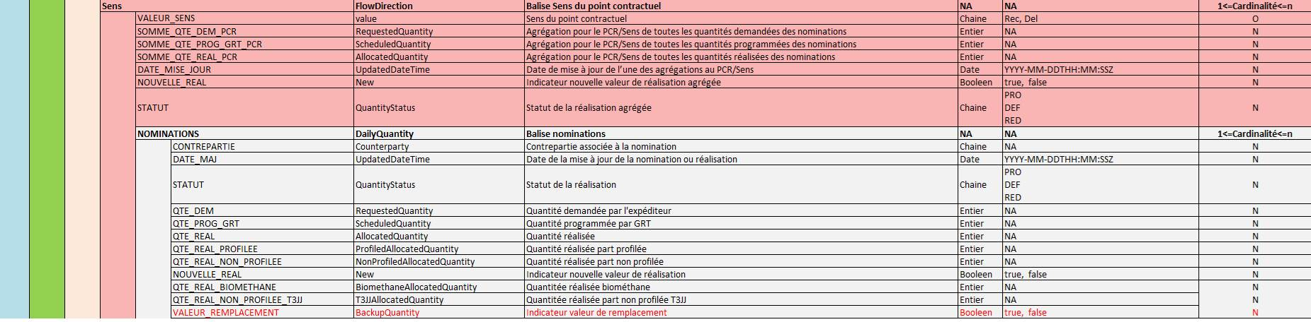

Below you will find the file that constitutes the xsd (Template) provided for the Allocation Notice exchange:



Example of file in csv format:



Example of file in xml format:

